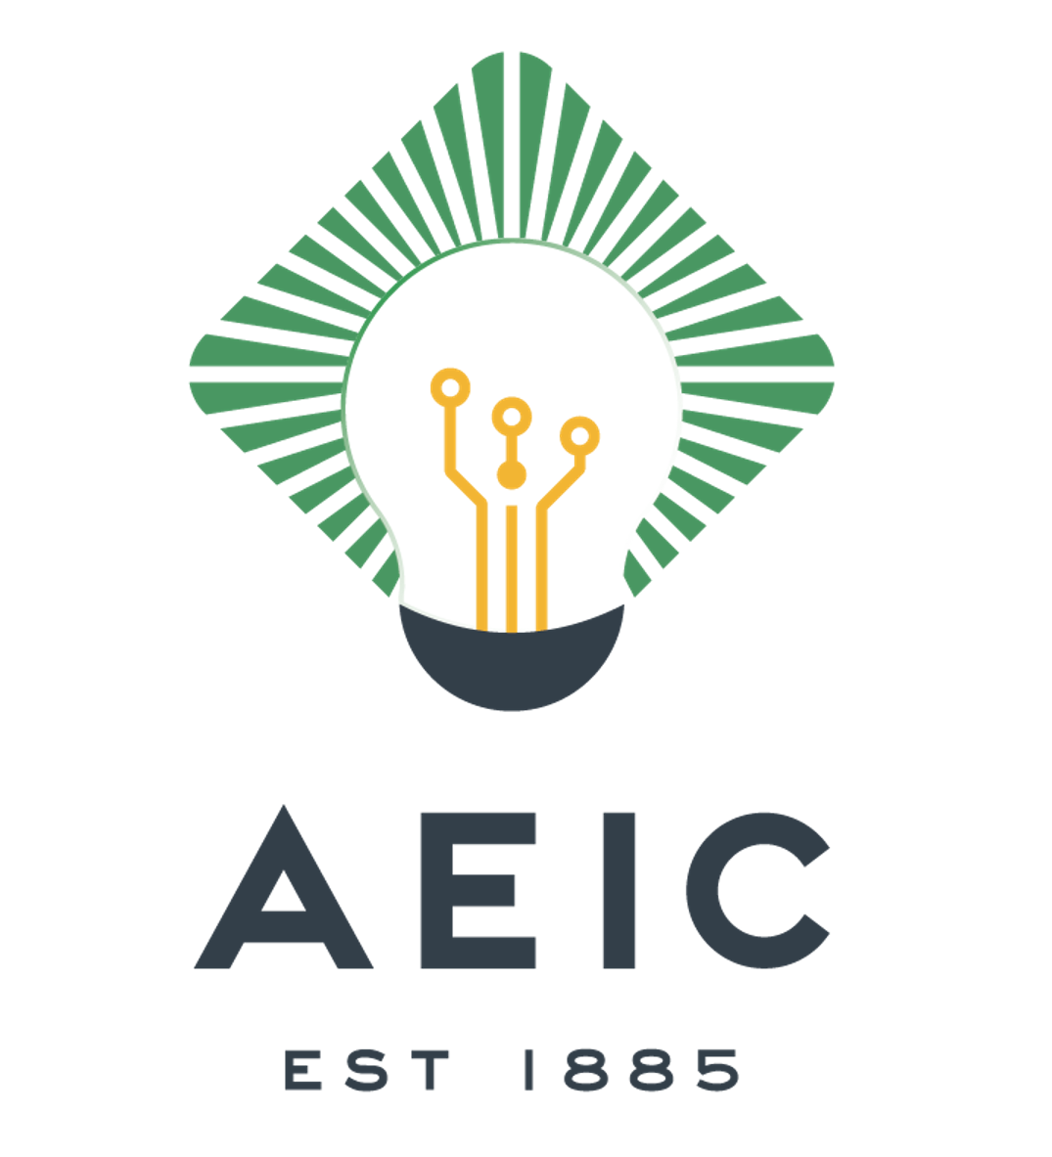 | Sponsored by:  AEIC Load Research & Analytics Committee  Visit http://www.aeic.org/  2024 COURSE & CONFERENCE SCHEDULE

Course/Price | Date | Location | Coordinator
Statistical Methods Course  $500 | April 17th-26th 2024 | Virtual Course  via MS Teams | Leslie Willoughby  SDG&E  (619) 922-7137  Lwilloughby@sdge.com
In person conference!  AEIC/WLRA joint Conference  San Antonio, BC  Fee $750  Registration Link [cvent.me] | Oct 7th – 9th 2024  Joint Conference  Oct 9th-10th 2024-AEIC  LR&A AEIC meeting,  $250 | The St. Anthony Marriott, a luxury collection hotel  San Antonio, Texas  Hotel Link [marriott.com] | Keith Kaysing  CPS Energy  (210)353-4846  kmkaysing@cpsenergy.com
Fundamentals Course  $500 | Tentative: Oct/Nov 2024 | Virtual Course  via MS Teams | Leslie Willoughby  SDG&E  (619) 922-7137  lwilloughby@sdge.com
Advanced Applications  $500 | March/April - 2025  4 – ½ days, T&TH, starts 12:00 to 5:00 Eastern Time | Virtual Course  via MS Teams | Leslie Willoughby  SDG&E  (619) 922-7137  lwilloughby@sdge.com

